**Lab 5 – MIPS Datapath for R-type and I-Type Instructions**

CECS 341 – Computer Architecture & Organization

Kenry Yu, 028210726

Olenka Bilinska, 028897191

Garret Towner, 028303091

Professor: Mandy He



California State University, Long Beach

College of Engineering

1250 Bellflower Blvd, Long Beach, CA 90840

April 13, 2022

**Goal/Objective:**

The goal of this lab is to modify the existing MIPS datapath for R-type instruction from lab 4 to support and implement I-type instructions.

**Technical Description/Steps:**

The first step of the project is to modify the control module of the MIPS datapath, we added several extra variables to determine the behavior and add a switch statement for the I-type instructions.

The second step of the project is to modify the datapath module of the MIPS datapath, we added several variables and wires in the module to connect the new variables added in the control module. We also added a few multiplexers to determine the data that we want to input to the ALU.

The third step of the project is to modify the testbench and import the new data files provided by the instructor. After that, we ran the testbench and compared it to our handwritten calculation.

**Results:**

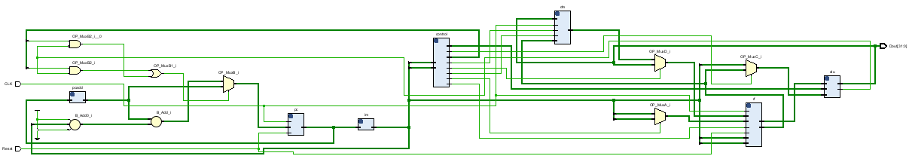

The image above is the schematic of the datapath module, it shows that our modules are connected together with the new multiplexers we added. In addition, the “DataMem.v” file provided by the instructor is also connected in the schematic.

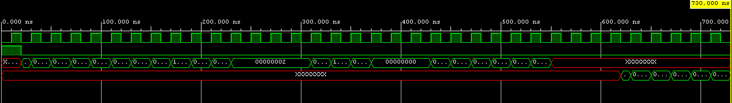

The image above is the waveform of the simulation of the MIPS datapath. The waveform shows the program began running after the reset turns to 0. After that, the program is fetched and decoded the instruction from the “DataMem.dat” and the “imem - Copy.dat” files. The program fetched the data from the register files, performed calculations, then stored the results back to the register files. The output of the ALU became “XXXXXX” in the waveform because there’s no output for store word instructions.

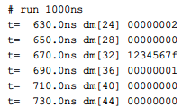

The image above is the console output of the program, it displays the result of the instructions that were stored in the specified registers. Our handwritten calculation matches the operation performed by the project, meaning that our module codes are working as intended.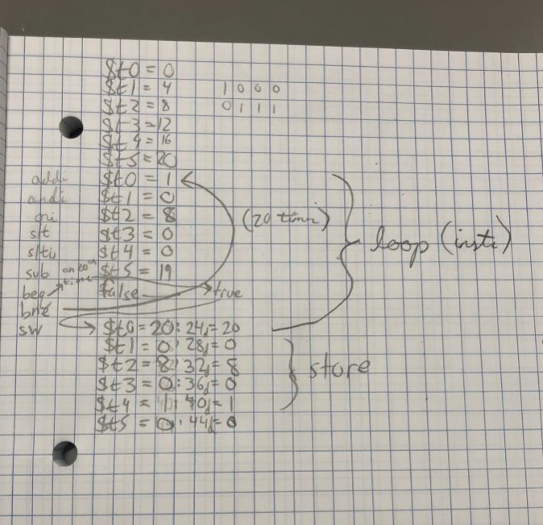

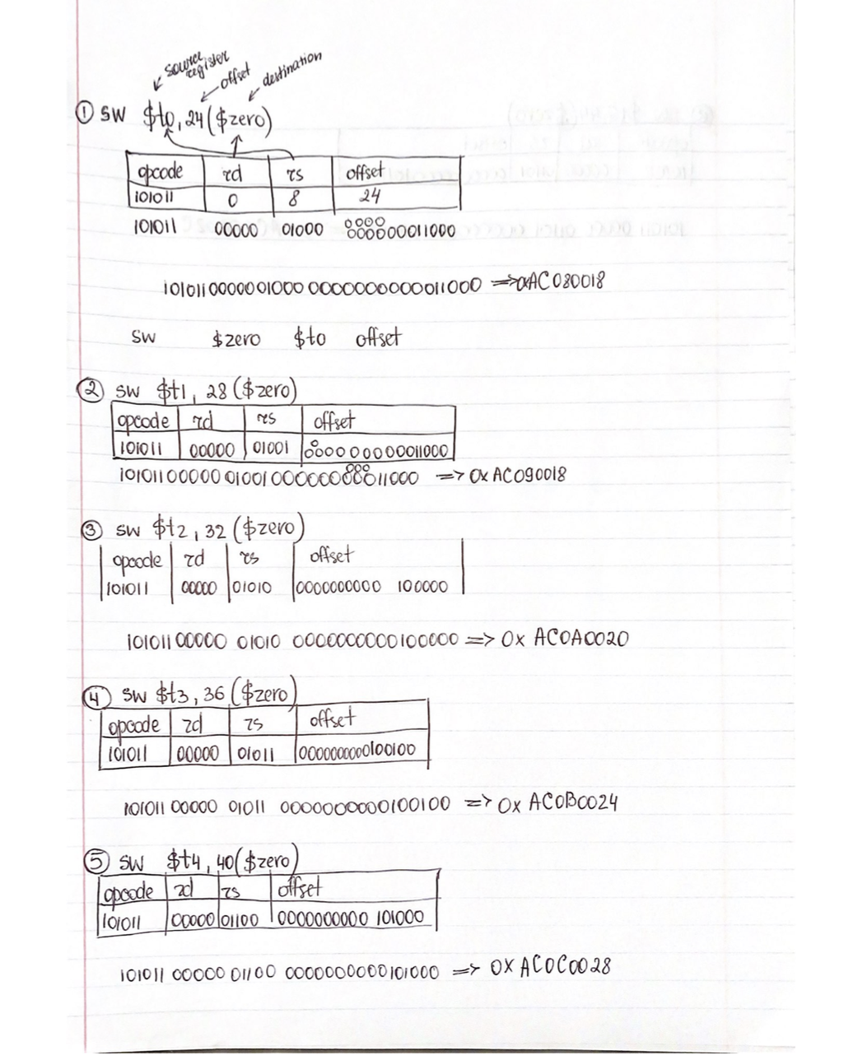

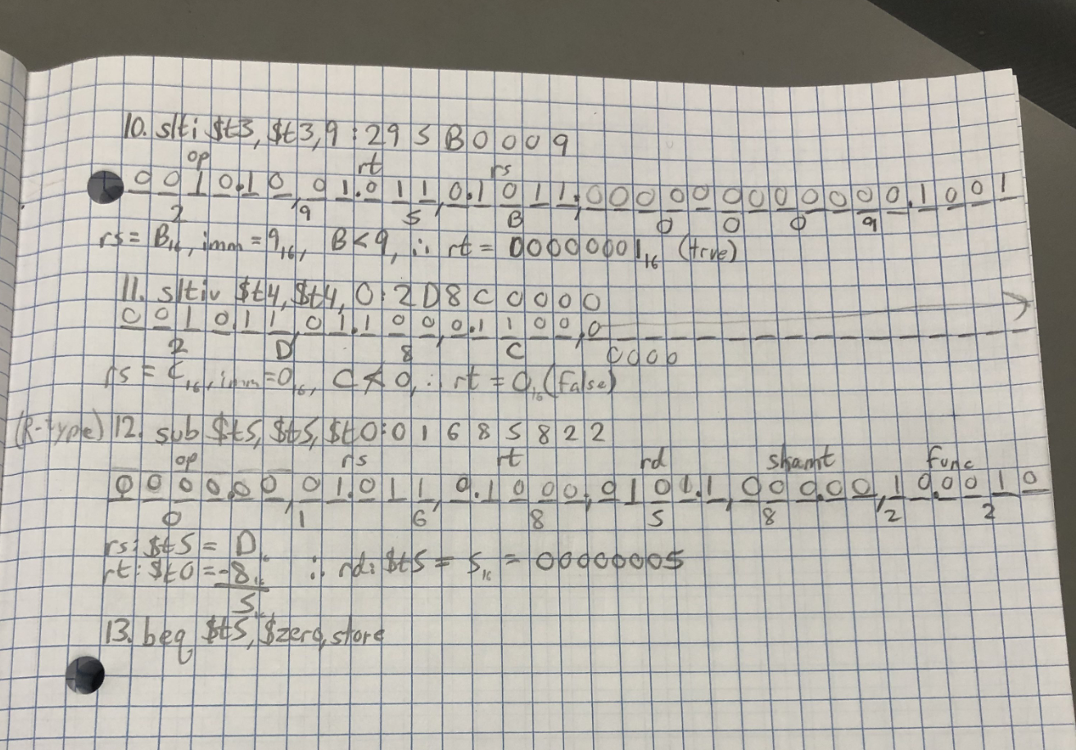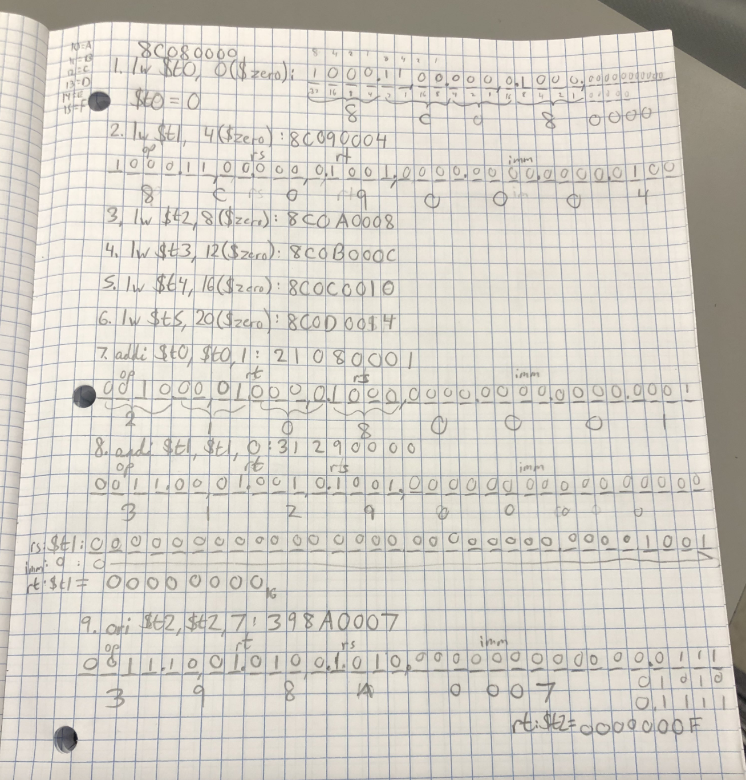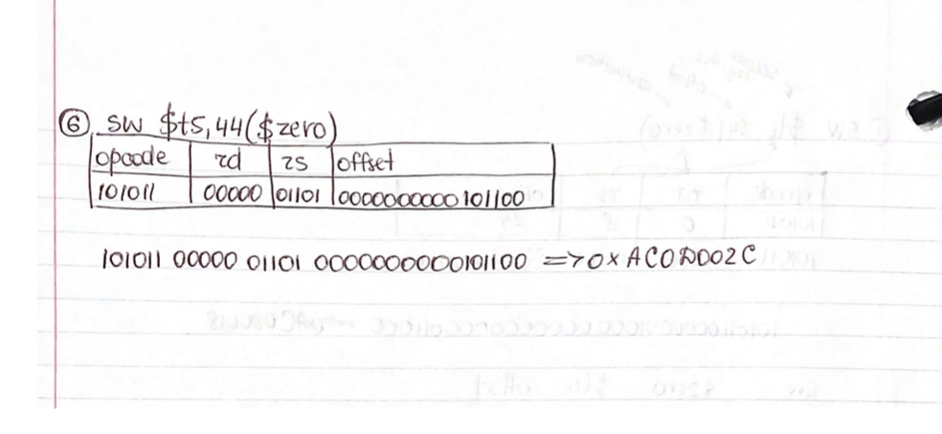

**Conclusion:**

In this lab, we learned how to modify the project from the last lab to support I-type instructions in the datapath. We also learned how to use the syntax for multiplexers to determine the input data that we want. Over the project, we encountered two challenges that slowed our progress.

First, our console output wasn’t displaying any numbers even when the waveform shows the program is running as intended. We realized that we were supposed to delay the display statement until when the store word instructions were completed. Moving the display statement under the time statement fixed the problem immediately.

Second, the result of the “slti” instructions does not match our handwritten calculation. After examining the behavior of “slti” instruction, we changed our codes in ALU and it began to output correct results.